**Name : Ahmed Sayed Taha**

**B.N: 68**

**Date : 1/6/2020**

**Topic:** **Programming Languages**

**Github link :** [**https://github.com/ahmedsayedtahaa/html-project-repository**](https://github.com/ahmedsayedtahaa/html-project-repository) **Github page :** [**https://ahmedsayedtahaa.github.io/html-project-repository/**](https://ahmedsayedtahaa.github.io/html-project-repository/)

**Application brief :**

**This project is about Programming Languages we will discuss production about it, types, importance and applications for example A programming language is a formal language comprising a set of instructions that produce various kinds of output. Programming languages are used in computer programming to implement algorithms. Most programming languages consist of instructions for computers. There are programmable machines that use a set of specific instructions, rather than general programming languages. Early ones preceded the invention of the digital computer, the first probably being the automatic flute player described in the 9th century by the brothers Musa in Baghdad, during the Islamic Golden Age and also has a lot of types for example Procedural Programming Language and Functional Programming Language ,** **Object-oriented Programming Language,** **Scripting Programming Language and Logic Programming Language  
  
  
  
  
  
Screeshots :**

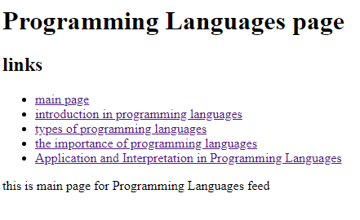

**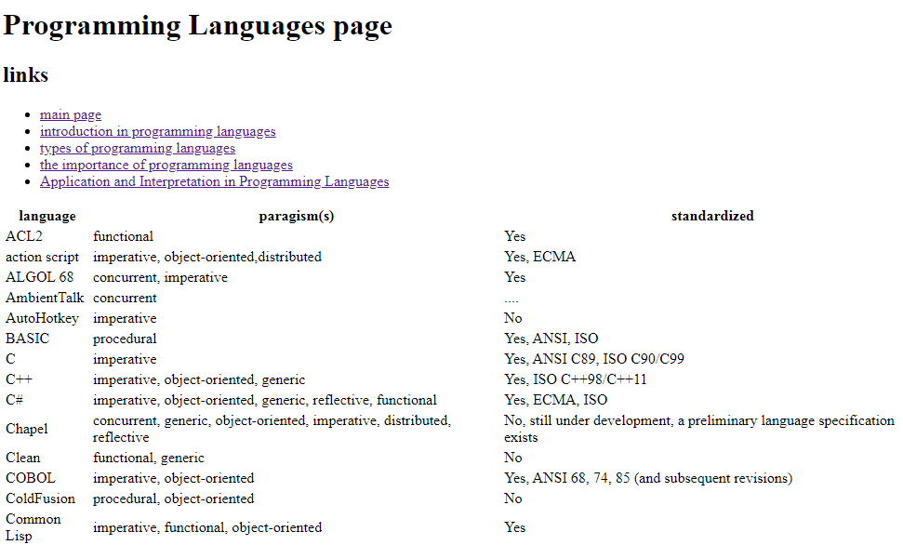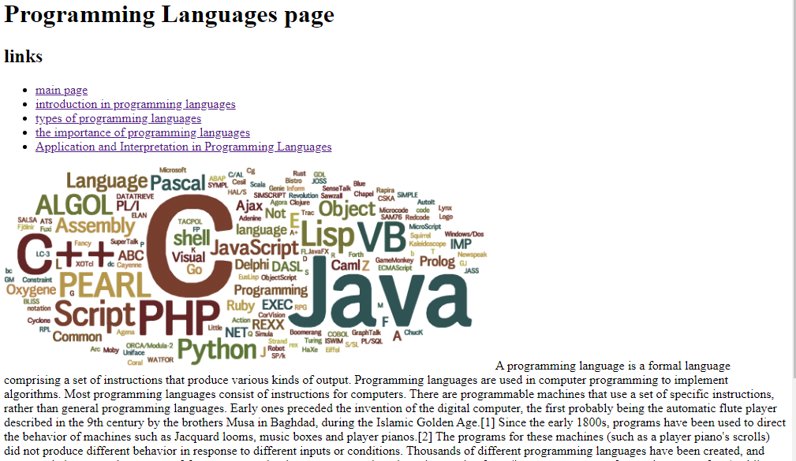  
source code:  
